**Wanted**

**For Eating Native Species**

**The American Bullfrog**

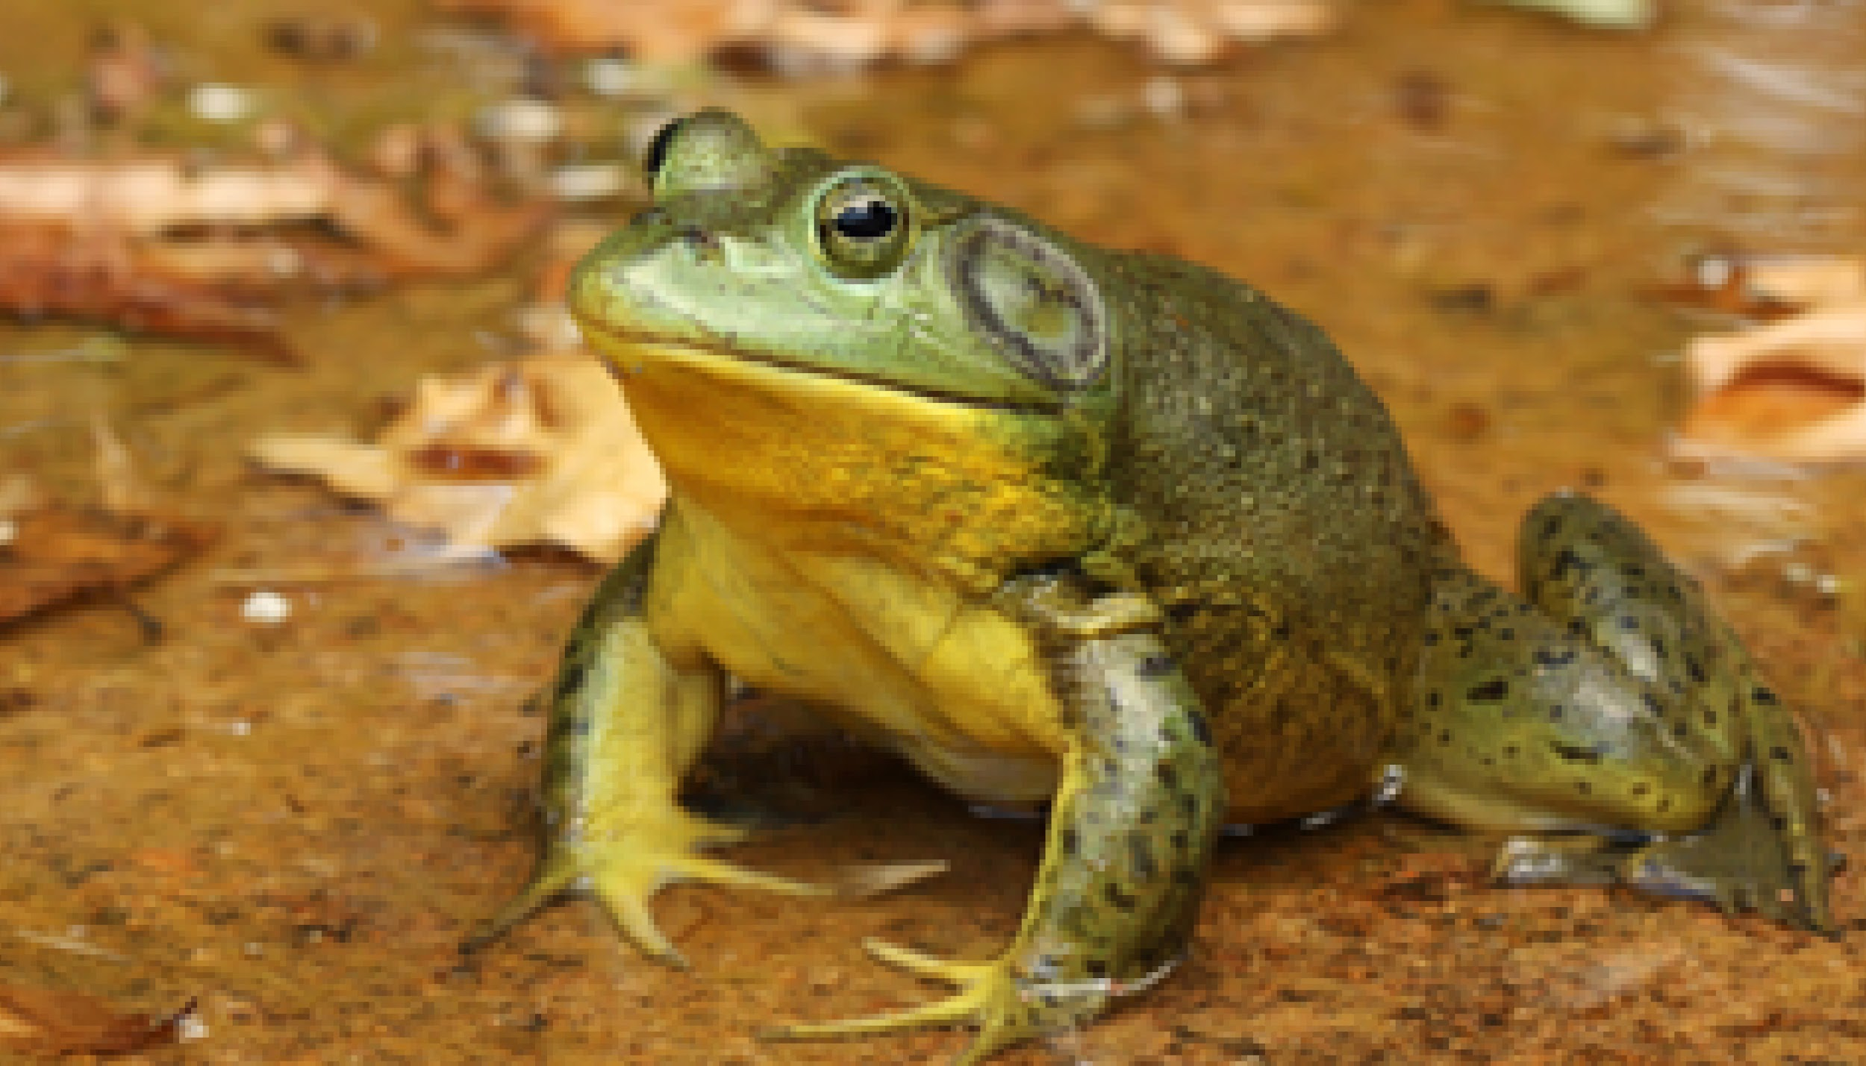

**Dead or Alive**

**Why is the American Bullfrog wanted?** It is wanted because it has invaded a non native ecosystem and it is doing harm. In their non native habitat they have been harming the ecosystem because of their large size and voracious appetite. Bullfrogs outcompete and prey upon many indigenous species.

**How to Spot the American Bullfrog.**

The American bullfrogs often have black polka dots on the top of the head and body, blotchy striping on the legs, and a whitish underside with gray mottling. They are green or greenish brown, and can be a light or dark shade. The back and sides may be plain or may have dark spots. The arms and legs are spotted or barred with dark.

**Last Seen.** The American bullfrog has been introduced throughout the western United States and the world. Their native range included the eastern U.S., extending into the Great Plains region.

**Suspected Hideouts.** The American bullfrogs favorite places to hide out are ponds, marshes, streams, and rivers

**How do the bullfrogs get around?** The American bullfrogs are native to the central and eastern United States. They have invaded the western United States including Hawaii. The bullfrogs were brought to the western United States as a food source and a biological control of insects.

**Crimes Committed.** Killed animals with toxic skin. Invasive bullfrogs also upset the balance of predator-prey interactions and competition for food and shelter.

**$ Reward $**

**1,000,000,000**

**Sources** <https://www.fs.usda.gov/detail/ltbmu/landmanagement/resourcemanagement/?cid=stelprdb5310346>

<https://www.keeptahoeblue.org/abouttahoe/invasive-species>

wildlife.ca.gov

Invasive species lake tahoe.

Wanted posters of the american bullfrog.

Where was the American Bullfrog last seen?

Why is the American Bullfrog poisonous?

How is the american bullfrog spotted?

Books too.

